MoonLite High Resolution Stepper Motor Rotator Option

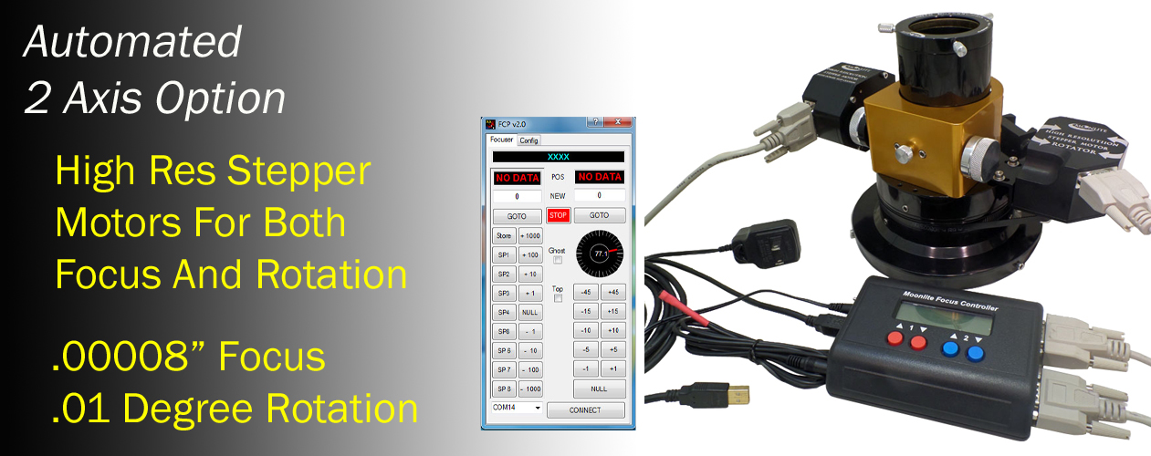

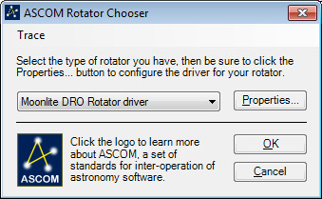
The MoonLite rotator spins the complete focuser including all imaging equipment connected at a .01 degree resolution. The kit comes as a user installed option for existing MoonLite 2” and 2.5” large format focusers. It uses the Dual Port DRO Display Controller for the original focus stepper motor and the new rotator stepper motor. The motor kit is a ¼” belt driven design that can be added easily. The rotator adds about 1.2” to the existing focusers profile, so please check to see if the extra profile is acceptable. Both focus and the rotator can be ran manually with the controller buttons or MoonLite’s non-ASCOM utility program, or with any ASCOM program. To install the MoonLite 64bit ASCOM driver (requires 6.0 ASCOM platform), see the download tab on our web page for latest software.
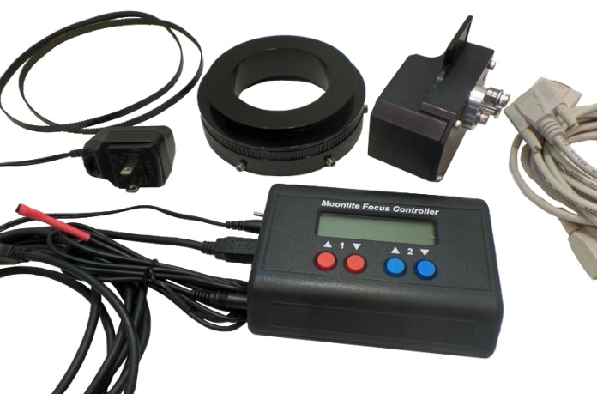
The installation kit includes the high resolution rotator stepper motor, drive belt, double bearing 1.2” thick rotator, dual port DRO display controller with remote temperature probe, and a spare ¼” wide drive belt. The rotator motor comes in 4 bracket sizes due to MoonLite’s focusers having different upper flange thicknesses and diameters.

-2” format for CS model focusers with .7” thick upper flanges
-2” format for CF model focusers with .85” thick upper flanges
-2.5” format for CSL, CFL focusers with .85” thick upper flanges
-2.5” format for CRL focusers with .55” thick upper flanges

See Video on installation process: https://www.youtube.com/watch?v=C0WYadI2IDE&feature=youtu.be

Configurations Available:
2” Rotator with high res stepper motor and dual port DRO display controller $935
2” Rotator with high res stepper motor stand-alone (no controller needed) $440
2.5” Rotator with high res stepper motor and dual port DRO display controller $985
2.5” Rotator with high res stepper motor stand-alone (no controller needed) $490
Stepper Motor Rotator Installation Procedure
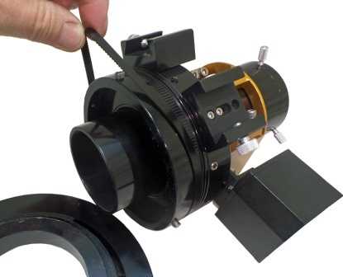
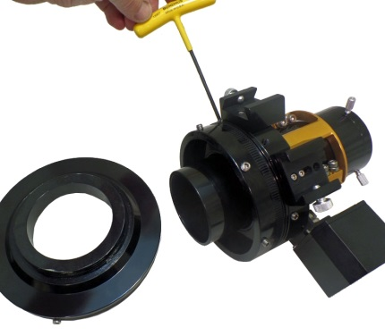
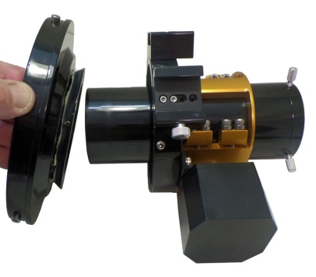
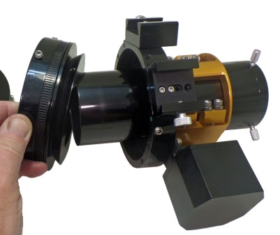
Step 1: Remove the lower flange of the focuser from the upper flange by backing out the 3 setscrews and aluminum thumbscrew. Twist and pull the lower flange off the upper flange (Please Note: there is white lithium grease between the flanges). Sandwich the new rotator between the upper and lower flanges. Tighten up the connection to the upper and lower flange as no manual rotation will be needed. The setscrews can be tight as they no longer adjust how easy the flange rotates. All rotation from this point forward will be from the rotator assembly itself.
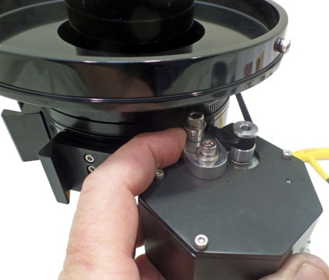
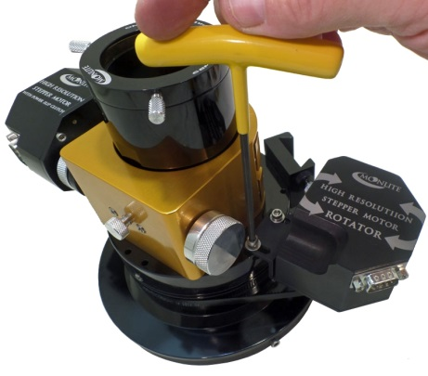
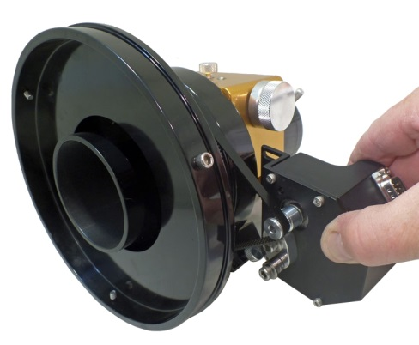
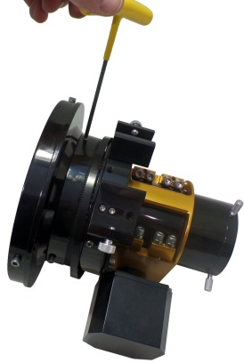
Step 2: Fit the cog belt over the rotating flange and wrap it around the gear teeth on the rotator. Next, wrap the belt around the motor pulley. Spin the belt tensioner out of the way as shown in the example photo. If it does not want to spin out of the way, loosen the locking cap head bolt with an Allen wrench and move it out of the way. Attach the stepper motor to the focuser with two #8 bolts, check the belt alignment and adjust the belt tensioners and tighten it up.
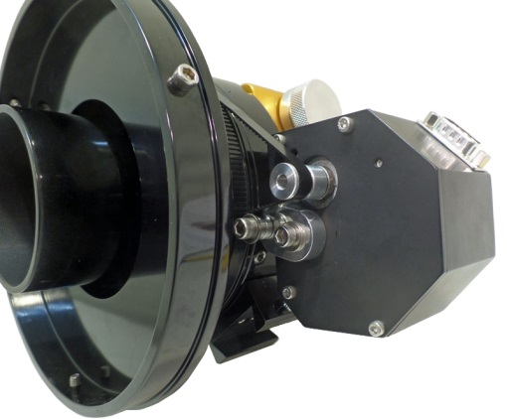
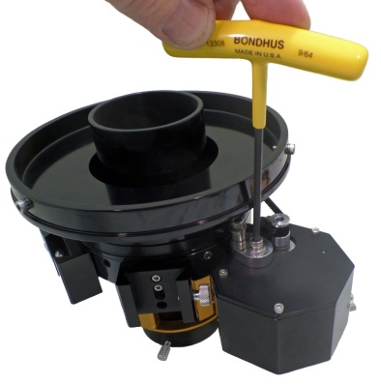
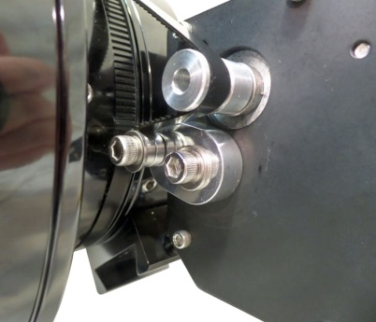

Step 3: Adjust the belt tension by swinging the belt tensioner lever so the roller bearings push into the belt. Lock the position by tightening up the center cap head bolt when the tension is correct. The tensioner needs to be locked into place once swung into position. Please test the rotator’s movement by running the motor with the hand controller. It should move smoothly and not jump any teeth on the gears if the belt tension is correct. Install software once the rotator is tested manually with the hand controller.
See Video on installation process: https://www.youtube.com/watch?v=C0WYadI2IDE&feature=youtu.be
Stepper Motor Rotator Software Install Guide and Operation
“Version – FCP dual 2.107”
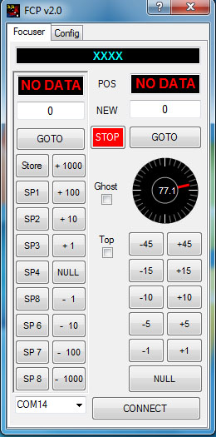
This non-ASCOM based program is designed to provide PC based automation of both focus and rotator capability of your MoonLite Focuser equipped with a high resolution stepper motor on both axis using the DRO dual port display controller. No ASCOM is required but Microsoft .NET Framework 4 is required for the installation. This install procedure is the same for our original FocuserNA1.07 software that handles Focus only (non-rotator version). This software will only work with the DRO dual port controller. It will not work with the original single port DRO display controller, the mini controller, or the mini V2 controller. This FCP 2.107 software works with all Win software OS such as XP, Win 7, and Win8 systems.

Download Focuser Setup.zip and extract the files to the default folder it requires. Please note: the PC should have internet connectivity for any updates windows may need to perform during the installation. Be sure to uninstall the old FocuserNA1.07 program before installing the new FCP 2.107 version. Go to Control Panel, then Programs, then Programs and Features to remove the original program. Both programs cannot be installed on the same PC at the same time.

Before running Setup, ensure that you have Microsoft .NET Framework 4 installed on your machine. This can be verified via: Control Panel/Add or Remove Programs. If Microsoft .NET Framework 4 is not installed on your machine, you can download it here: http://www.microsoft.com/downloads/en/details.aspx?FamilyID=9cfb2d51-5ff4-4491-b0e5-b386f32c0992&displaylang=en . Windows will access the web and update Net framework automatically if needed once you start installation.

Next, verify your controller is connected to your PC and turned on. Click on the Zip file to start the installation
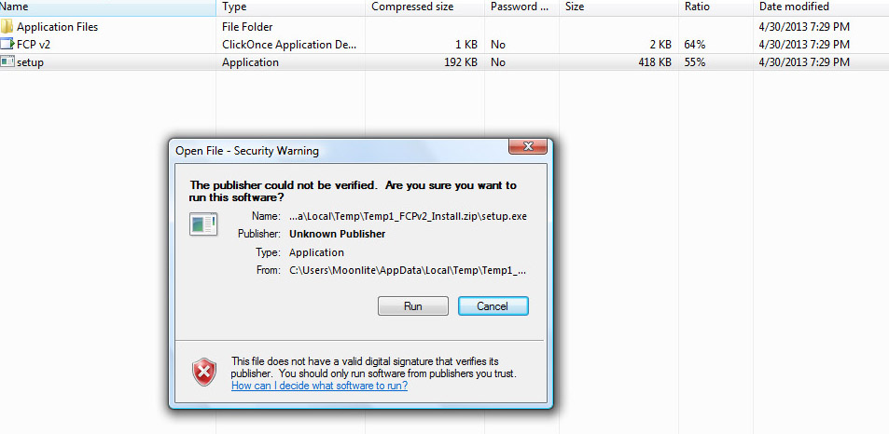

Run "Setup”: (Be patient, the program will verify that you have the correct .NET Framework and will populate a list of Com Ports in use).
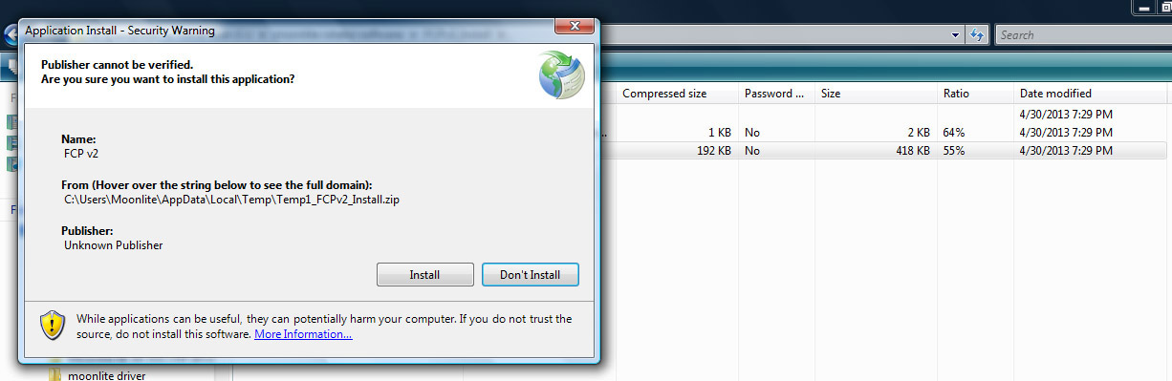

Continue with the installation and the program will launch.

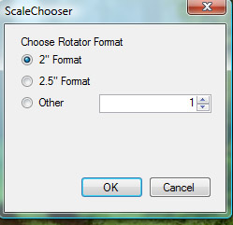
Pick the focuser format size you have. This will set the resolution scale in the software to the correct value.

The Focuser program will start up. Click the connect button to activate to the controller.

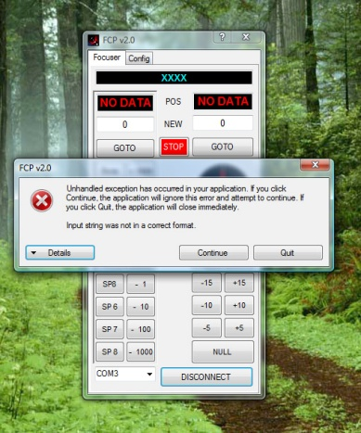
If an error message pops up like below, then check the com port setting in the lower left corner. The controller may be assigned to a higher number port.

If it still will not connect, check to make sure your PC has the correct USB driver. If your laptop is older, you may need to install the latest USB driver. To install the driver download the VCP (virtual com port) driver for the FT232R chip from http://www.ftdichip.com/Drivers/VCP.htm Unzip using your favorite zip file utility to a directory of your choice. Connect power to the focus controller and the USB cable to your computer and the focus controller. Windows will state that it has found new hardware and needs to install drivers. When prompted, select “Have Disk” and select the directory where the files were unzipped. The installer should then complete the software installation.

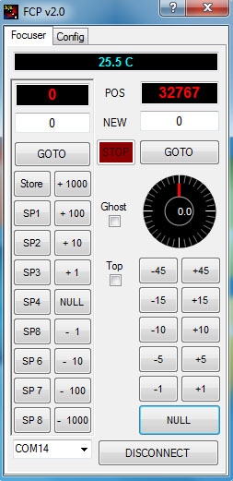
Operation: Left side is for focus, Right side is for rotation.
Step count is displayed in red for both focus and rotation position. Manual values can be entered in the “White box”, then click GOTO to move to that position. Up to eight focus positions can be stored in the SP buttons; however, the value must not be zero. The “Null” button on the left focus side will zero the count to the current position. Normally, the focuser is in the fully racked down position before “Null” is pressed. The controller will not allow a negative step count, so be sure to “Null” the position after racking the focuser the whole way down. The step count will increase in a positive value as the focuser racks up from the fully down position. The step count will be about 6250 steps per inch in full step mode. Focus position can be racked up/down by manually entering any step count value and clicking GOTO button. Focus position can also be moved by clicking the +1 button, +10 button, etc. Please note: all step count values must be between 0 and 65534. That is the limit range set in the controller.
The Null button on the rotator side will set the step count to 32767. This is the midway point in the step count range and allows CCW rotation down to 0 step count, and CW rotation up to 65534 step count. Your focuser and cables should be oriented in a level mid position before hitting the “Null” button to set the midpoint. Once the focuser is level and the null button is clicked the software will set the degrees to zero. The focuser can now be rotated to any position from 0 to 360 degrees in .01 resolutions. Angle positions can be entered manually by entering the degree number in the white box, then click GOTO. The rotation angle buttons 1 degree, 5 degree; etc. can also be used for quick moves. Cable management limits will stop the focuser from rotating past 200 degrees in either direction. A message will come up saying “Mechanical Limit Reached”. Please note: you may see the “Mechanical Limit Reached” warning when first connecting the controller to the software and focuser. This is due to the focuser not being nulled yet and it trying to move to random positions in memory. If this happens and the focuser starts to move during first installation, click the stop button to stop it and then “null” the position. The controller will remember its position after everything is nulled for the first time, even when power is restored.
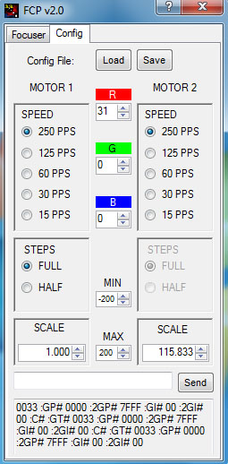
The Configuration tab will allow settings to be adjusted by the customer.

The scale setting on the bottom right for rotation should be 94.167 for 2” format focusers and 115.833 for 2.5” large format focusers. This value represents steps per degree and can be changed if needed. Please note: full step mode is the only supported mode for the rotation side. Half step mode is not allowed and is greyed out.

Speed on both the focus side and rotator side can be adjusted from full speed at 250 down to 15. Both sides should be set to 250 as this allows the focuser to move at its fastest pace. There is no practical reason to slow down the controller moving the focuser, so please leave the setting at 250. A lower setting will just increase the delay or time between steps which in turn makes the moves appear slower.

The display color and brightness on the controller can be adjusted using the RGB buttons. Load and save buttons are for saving SP button focus positions and renaming the buttons on the focus side. Cable management limits can be changed by the customer from the default of 200 degrees in both directions. The Value can only be decreased not increased beyond 200 as that is the upper limit in the software. Please do not set cable management angle limits less than 180 degrees. This can cause the focuser not to be allowed to rotate to all 360 degree locations.

Trouble Shooting
If the software will not install, Net frame is either an old version or not on the PC. Please make sure the PC has internet connectivity to allow Net frame to update and install correctly.
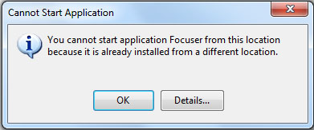
If you get an error message when attempting to install the new software, be sure to uninstall the older MoonLite FocuserNA1.07 program first. Go to Control Panel, then Programs, then Programs and Features to remove the original program. Then return to installing the new FCP 2.107 software. Both programs cannot be installed on the same PC at the same time.

If the controller will not connect, make sure your PC has an updated USB driver. All controllers require a modern Uart driver to connect to the PC using the USB port. If you are using an older PC or it is not connecting, please download the latest drivers from: http://www.ftdichip.com/Drivers/VCP.htm

If it times out trying to connect, select a different com port (Devise manager can help show port assignments), or download the driver noted above.

Serial communications traffic between the software and the controller can be seen in the bottom serial data log traffic box when in the configuration tab. This can be helpful for trouble shooting or verifying operation. Customers can also send raw commands directly to the controller from the software. This can be helpful if temperature calibration needs adjusted. Temp value offsets can be sent to the controller to adjust the displayed temp value up or down.

For Example: if you want to adjust/calibrate the temp display, just type in PO02 in the box and hit send. This will change the temp offset positive by 1 degree. A PO04 command would adjust it by 2 degrees. A POFC command would adjust it -2 degrees. All serial commands are in Hex. Please see serial command list in the high resolution stepper motor document for a complete list of serial commands.
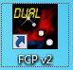
This software is only for the Dual Port Display controller and will not work with any other MoonLite controller. The icon will say “Dual” for this rotation software. Other than the word “Dual” the icon for both looks the same. Please use FocuserNA1.07 software for all other MoonLite controllers without rotation ability. The original software works with all MoonLite controllers, even the dual port, but does not have any rotation section the software.

MoonLite Telescope Accessories
755 Preserve Road, Danville, PA 17821-7909
Phone/Fax 570-437-2232
www.focuser.com
Rev. 07-2016
Revv. 07-2016

